Exp No : 8
Gas Sensor MQ-2 in Proteus Using Arduino
AIM: To write an Embedded C program for interfacing Gas Sensor MQ-2 using Arduino Uno and Proteus
SOFTWARE REQUIRED:
- Proteus 8 software.
- Arduino IDE software
Program :
#define GreenLed 13
#define Sensor A0

void setup()
{
pinMode(GreenLed, OUTPUT);
pinMode(Sensor, INPUT);

Serial.begin(9600);
}

void loop()
{
int value = analogRead(Sensor);

Serial.print("MQ-6 Sensor Value: ");
Serial.println(value);

if (value > 600)
{
digitalWrite(GreenLed, HIGH);
}
else
{
digitalWrite(GreenLed, LOW);
}

delay(1000);
}
OUTPUT :
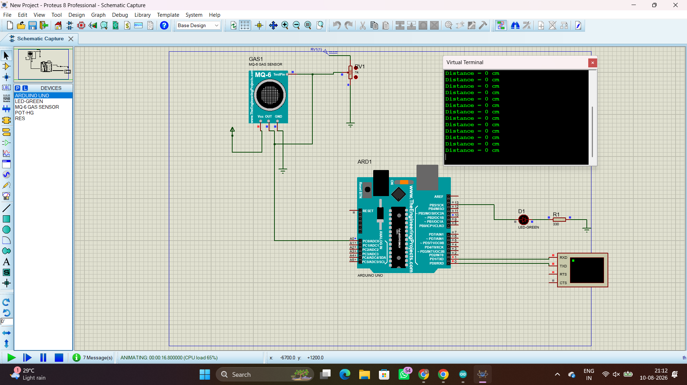
RESULT :
Thus the program has been successfully verified and executed.

